McHF QRP Transceiver Build Guide

for RF board 0.4 and UI Board 0.4

W1BAW Bruce Wattendorf

2015

MCHF Build Guide

Description of radio and what to expect.

What you need to build

What you might want to get to make it easier.

Start building

Power section

On the Rf board solder F1, D1, C27, R11,R12, C30, R10, R13, R14, D2, U5, C28, C29 , U4, U3 , J1

Test by connecting up 12 volts to J1

Computer

Apply the firmware

Build the audio Codex

Build the local oscillator

Build the RX mixer

Build the Bandpass filter section

Build the antenna switching

The McHF radio is a QRP Amateur radio transceiver. It is a small, home-brew amateur radio project. It was designed to be as cheap as possible – without sacrificing functionality – and include the ability to add new features via simple software updates.

The choice of architecture is a direct conversion receiver and transmitter, with a small micro-controller to provide control and DSP functions. The analog blocks in this implementation were kept to the bare minimum. Shifting, as much as possible, functionality into the digital domain.

The receiver features: a SN74CBT3253C Tayloe detector as a direct conversion mixer – Local Oscillator frequency is four times higher than the receive frequency;  a digitally switched band pass filter; voltage controlled attenuator and pre-amp situated in the RF signal path before the actual direct conversion process. The resulting IQ audio signals from the detector are sent to the WM8731 Codec for conversion to digital data, and then via I2S bus to the STM32F4 controller.  The decoding of the different modes (SSB,AM and CW) is then performed by DSP routines inside the CPU. Finally, processed audio is sent back to the CODEC chip and outputted via the speaker or LINE OUT output.

The transmitter uses a reverse process of mixing four channels of audio data with the LO signal. The result is amplified by the linear amplifier and passed via digitally switched LPFs into the antenna output. As with the receiver, the CODEC processes audio from a microphone or LINE IN to convert it to digital data where it is sent on to the CPU for DSP processing. Here IQ data is generated and sent back to the CODEC. When in CW mode, software defined DDS is used to generate side-tone, controlled by an iambic keyer. Resulting IQ data is sent in the same way to the CODEC for conversion to analog signals and passed on to the tx mixer.



The architecture so far is no different than similar direct conversion QRP kits and projects. I have tried to further ‘digitise’ the design and add some ideas which might prove to be useful over time:

* Temperature sensor on the I2C bus, attached physically to the local oscillator(SI570). Small tcxo routine in the firmware can help improve the frequency stability for digital modes
* Voltage controlled physical attenuator in front of the RF pre-amp, controlled by the CPU built in DAC, hopefully providing better control over strong signals
* Digitally controlled BIAS for the final linear amplifier – simple PTT control, and no need for unreliable analog trimmer pots
* LPF switching via latch relays – lower power consumption avoiding thermal strain on the contacts
* Keypad with each button connected to separate GPIO pin instead of scanning matrix keyboard – lower noise and intermodulation products
* Single CPU clock of 16Mhz, well outside of ham bands for the fundamental and harmonics, TCXO with high stability
* CODEC main clock provided by the CPU PLL, high stability, very suitable for digital modes
* Constant LCD brightness, to avoid using TIMER PWM output, another way to avoid stray interference from the CPU to sensitive RF parts
* And finally simple power on/power off circuit, fully soft controlled, virtually no current draw when the transceiver is off.

A really good description of software defined radio can be found on DH1TW’s web site [here](http://www.dh1tw.de/understanding-the-sdr-concept)

There is a McHF Yahoo support group that was started by Andy (G6LBQ) [here](https://uk.groups.yahoo.com/neo/groups/M0NKA-mcHF/info).

Most questions and updates can be found there.

**Availability of parts**

The Boards and LCD displays can be purchased from Chris M0NKA on the McHF web site. [HERE](http://www.m0nka.co.uk/?page_id=740)

There is no kits or one place for all the components yet. On the Yahoo group there is BOM “bill of materials” lists as well as lists on the McHF site. The list is at the end of this document but does not list the part suppliers part numbers only the manufacture part number.

Most of the rest of the parts can be obtained from Farnell in the UK and Europe.

From Mouser and Digikey in the USA. Some of the power and audio jacks will need to be bought from the UK from Farnell because there is no US suppliers as of this documents date.

From the Author

This document was written by Bruce Wattendorf W1BAW and I got the design from Robbie WB5RVZ and his site WB5RVZ.org. This is a SoftRock build guide site. I can be contacted by email at bwattendorf@gmail.com.

**Rx Circuitry**

Description of rx circuit

**TX Circuitry**

**Project Schematic**

**RX Schematic**

**TX Schematic**

**Project Bill of Materials**

Add links to bill of materials

**Board Layouts**

Look for good board layouts pictures for the boards

**Ensemble RXTX Detailed Build Notes**

For the non-expert builders among us, this site takes you through a stage-by-stage build of the kit. Each stage is self-contained and outlines the steps to build and test the stage. This ensures that you will have a much better chance of success once you reach the last step, since you will have successfully built and tested each preceding stage before moving on to the next stage.

Each stage is listed below, in build order, and you can link to it by clicking on its name below (or in the header and/or footer of each web page).

* Build and Test the [Power Supply](http://www.wb5rvz.org/ensemble_rxtx/01_ps) stage.
* Build and Test the Micro processor stage.
* Build and Test the Audio stage.
* Build and Test the [Local Oscillator](http://www.wb5rvz.org/ensemble_rxtx/03_lo) stage.
* Build and Test the [Dividers](http://www.wb5rvz.org/ensemble_rxtx/04_div) stage.
* Build and Test the [RF I/O and Switching](http://www.wb5rvz.org/ensemble_rxtx/05_rf) stage.
* Build and Test the [RX Mixer (QSD)](http://www.wb5rvz.org/ensemble_rxtx/06_mix) stage.
* Build and Test the [RX Opamps and Output](http://www.wb5rvz.org/ensemble_rxtx/07_opamp) stage.

# S**tage-By-Stage Testing**

Each stage will have a "Testing" Section, outlining one or more tests that, when successfully completed, provide you with the confidence and assurance that you are heading in the right direction towards a fully tested and built transceiver.

When you perform a test, you should always record the results of the test where indicated in the Testing section. This will make troubleshooting via the reflector much easier, since you will be communicating with the experts using a standard testing and measurement regime.

**When comparing measurements to those published in these notes, the builder should be aware that actual and expected values could vary by as much as +/- 10%. The idea behind furnishing "expected/nominal" measurement values is to provide the builder with a good, "ballpark" number to determine whether or not the test has been successful. If the builder has concerns about his measurements, he should by all means pose those concerns as a query in the MCHF Yahoo group so others can provide assistance.**

**It goes without saying that you should ALWAYS precede any tests with a very careful, minute inspection (using the best light and magnification available to you) to be sure all solder joints are clean and there are no solder bridges or cold joints.**

**This radio can be built and reliably tested using nothing more than a common multimeter. Tests assume that the builder has a decent digital multimeter of sufficiently high input impedance as to minimize circuit loading issues.  Measurements will be taken of current draws, test point voltages, and resistances.**

**Most stages will have a current draw test, in which the builder tests the stage's current draw in two different ways:**

* **First, testing the draw through a current-limiting resistor**
* **Then, when that test is OK, removing the current-limiting resistor and measuring the real current draw.**

**Some tests will require you to use your ham radio to receive or generate a signal of a specified frequency in order to test transmitters, oscillators, dividers, and/or receivers.**

**Optional testing. If the builder has (access to) a dual channel oscilloscope, along with an audio signal generator and an RF signal generator, and feels the need to perform tests beyond the basic DMM tests, certain stages will include in their testing section some optional tests involving this advanced equipment.**

**The [IQGen](http://dl6iak.ba-karlsruhe.de/projects/2001-04-28.htm) or**[**DQ-Gen**](http://dl6iak.ba-karlsruhe.de/projects/2000-07-01.htm)**programs available free from Michael Keller, DL6IAK, can be used in a pinch to get the sound card to produce audio tones for injection into the circuit.**

**Completed RF board**

Top View

Bottom View

**Completed UI board**

Top View

Bottom View

**Background Info**

**Component Identification**

After soldering problems, the most common cause of trouble in radio building is the installation of the incorrect component. Most often this is the case with resistors (hint - if voltage or current draw tests are way out of whack, suspect resistors or solder bridges). Invest in a cheap multimeter and MEASURE the resistance.

#### **Soldering**

If you are not experienced at soldering (and even if you are somewhat experienced at soldering), refer to [excellent tutorial on basic soldering techniques by Tom Hammond N0SS (SK).](http://www.mmccs.com/mmarc/n0ss/soldering_tips_v8.pdf)

This video provides some excellent hints at soldering (and de-soldering) SMT components:

The video below describes techniques for soldering SOIC 14 (and 16 and 8) SMDs

[View the above in full-screen mode on Youtube](http://www.youtube.com/watch?v=lauw0bSe-Cw).

You may also want to review the information from the HamNation series on George, W5JDX, and his build of the Softrock Ensemble RXTX which the MCHF was based off of. He uses an inexpensive heat gun and Solder paste to install SMT capacitors and ICs. The Session where he introduces the process is in [Episode #70](http://twit.tv/show/ham-nation/70) at 36 minutes, 30 seconds into the podcast.

For the more adventurous, there is a process using solder paste and an electric oven called the reflow process, which can be used to install all the SMT chips to one side of the PC Board. This is documented by Guenael Jouchet in the following Youtube segment:

* Read the [Primer on SMT Soldering](http://www.sparkfun.com/datasheets/Prototyping/General/SMD-SolderingWorkshop.pdf) at the Sparkfun site.  It is a very good read and it speaks great truths.  Then take the time to watch the [video tutorial on soldering an SOIC SMD IC](http://www.sparkfun.com/tutorials/96).
* Solder Stations. Don't skimp here. Soldering deficiencies account for 80 percent of the problems surfaced in troubleshooting. It is preferable to have an ESD-safe station, with a grounded tip. A couple of good stations that are relatively inexpensive are:
  + 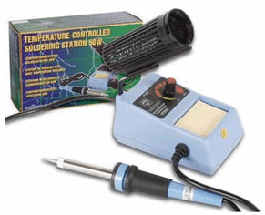

Velleman [VTSS5U 50W Solder Station](http://shop1.frys.com/product/4825190;jsessionid=JgkkdKH3TaF0Y-KUZY+jHQ**.node2?site=sr:SEARCH:MAIN_RSLT_PG) (approx $25 at Frys) ([See BGMicro for Spare Tips](http://www.bgmicro.com/ACS1580SpareTipForACS1503.aspx))

* + 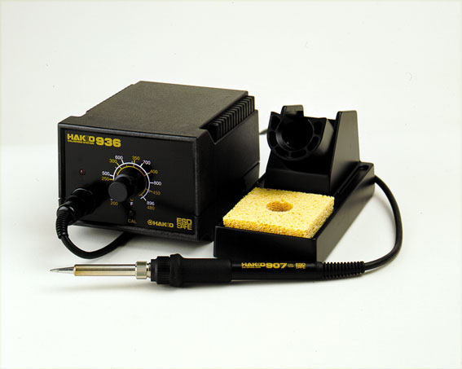

Hakko (Aoyue) 936 [ESD Solder Station (under $100)](http://www.frys.com/product/7742028)

**ESD Protection**

* Avoid carpets in cool, dry areas.
* Leave PC cards and memory modules in their anti-static packaging until ready to be installed.
* Dissipate static electricity before handling any system components (PC cards, memory modules) by touching a grounded metal object, such as the system unit unpainted metal chassis.
* If possible, use antistatic devices, such as [wrist straps and antistatic mats](http://www.tigerdirect.com/applications/SearchTools/item-details.asp?EdpNo=1472803&CatId=1802) (see [Radio Shack's Set](http://www.radioshack.com/sm-anti-static-products--fi-2032309_cp-2032058.2032236.html) for $25 or the [JameCo AntiStatic mat](https://www.jameco.com/webapp/wcs/stores/servlet/ProductDisplay?storeId=10001&langId=-1&catalogId=10001&pa=10584&productId=10584) for $15)).
* Always hold a PC card or memory module by its edges. Avoid touching the contacts and components on the memory module.
* Before removing chips from insulator, put on the wrist strap connected to the ESD mat. All work with CMOS chips should be done with the wrist strap on.
* As an added precaution before first touching a chip, you should touch a finger to a grounded metal surface.
* If using a DMM, its outside should be in contact with the ground of the ESD mat, and both leads shorted to this ground before use.
* See the review of ESD Precautions at this [link](http://support.necam.com/mobilesolutions/hardware/esdhandle.asp).

**Work Area**

* You will need a well-lit work area and a minimum of 3X magnification (the author uses a cheap magnifying fluorescent light with a 3X lens. This is supplemented by a hand-held 10 X loupe - with light - for close-in inspection of solder joints and SMT installation.
* You should use a cookie sheet or baking pan (with four sides raised approximately a half an inch) for your actual work space. It is highly recommended for building on top of in order to catch stray parts, especially the tiny SMT chips which, once they are launched by an errant tweezer squeeze, are nigh on impossible to find if they are not caught on the cookie sheet.

**Misc Tools**

* It is most important to solidly clamp the PCB in a holder when soldering. A "third-hand" (e.g., [Panavise](http://www.panavise.com/index.html?pageID=1&id1=1&id2=8&startat=1&--woSECTIONSdatarq=8&--SECTIONSword=ww) or the [Hendricks kits PCB Vise](http://www.qrpkits.com/pcbvise.html)) can hold your board while soldering.   In a pinch, you can get by with a simple [third-hand, alligator clip vise](http://www.toolsgs.com/cart/detail.asp?cat=2&subcat=35&product_id=H201). Jan G0BBL suggests "A very cheap way is to screw a Large Document Clip to a woodblock which will clamp the side of a PCB."
* Tweezers (bent tip is preferable).
* A toothpick and some beeswax - these can be used to pickup SMT devices and hold them steady while soldering.
* Diagonal side cutters.
* Small, rounded jaw needle-nose pliers.
* Set of jewelers' screwdrivers
* An Exacto knife.
* Fine-grit emery paper.
* Magnifying Head Strap, or +2 to +3 reading glasses, or USB microscope (can be bought on Ebay for less them $100.00 usd.
* 12 volt DC power supply with power meter used to measure current.

If you are going to be using the hot air gun method then the following is recommended

* solder paste can be bought from [kd5ssj.com](http://kd5ssj.com/solderpaste) his site also has some very good tips
* hot air gun embossing guns can be bought from Ebay or amazon for less then $20.00 USD or a professional hot air gun made for SMT electronic rework can be found for less then $100.00 USD. The embossing gun can blow the parts out of alignment because of the air pressure where the profession air rework station normally has adjust air pressure.

**Parts 1 McHF – RF 0.4 Power Supply   
Introduction**

**General Info about the Stage**

In this first (and following) stages, the builder should remember that one of the most common causes of errors is soldering. It pays to review materials on soldering, get help from Elmers, or whatever you can do to make your solder joints as clean and properly conductive as possible!

The second most common cause of errors is installation of the WRONG component and/or installing the component in the wrong ORIENTATION. The old rule of "measure twice, cut once" clearly applies to this project. When you order the parts it is recommended that you don’t remove the parts from the bags they come in till you are ready to solder them and also replace any not used back in the bag to reduce this issue.

The remaining one-tenth of one percent of the causes of errors is the defective component - most suspect the component immediately; the intelligent rarely look first at possible component failure.

**Theory of Operation**

mcHF uses a chain of linear regulators to provide all needed voltages. The top one is software controlled from the MCU. Linear regulators chain was chosen against switching supply for simplicity and easier EMC management.

F1 is a poly fuse that will reset when triggered, also D1 is there to prevent damage from reverse voltage.

Note that there are actually four power busses:

Voltages needed by mcHF – 12V for final PA, 8V for the speaker amp and TX quad preamp, 5V for most of the RF modules, LCD etc. and 3.3V for the digital logic – MCU and Codec. The main concern here is the voltage drop in the chain to be as small as possible because eventually it is converted to heat. As the first two regulators use the output PA transistors heatsink, this is a concern. So the drop in U3 is 12 – 8.5 = 3.5 V, the drop in U4 is 8.5 – 5 = 3.5 V and finally U5 drop is 5 – 3.3 = 1.7 V.

The way power up works is by holding the U3 INHIBIT pin high from the incoming 12V supply via divider R9/R10. The idle voltage is 2.6V, enough to keep the regulator in OFF mode and not give to much reverse current to the MCU GPIOs connected via D2. Pressing the power button on the UI pcb will provide low level to the pin 3 of U3, which will put the U3 in ON state, which in turn will cause the MCU to boot and execution of the startup firmware routines will provide constant low level to D2 and keep the U3 ON. Power off is just switching MCU GPIO pin to high and powering off the whole regulator chain.

The RF board uses 12 volts DC tip positive.

**Summary Build Notes**

1. [Install Topside Components](http://www.wb5rvz.org/ensemble_rxtx/01_ps#installtopsidecomponents)
2. [Test the Stage](http://www.wb5rvz.org/ensemble_rxtx/01_ps#testing)

**Stage Schematic**

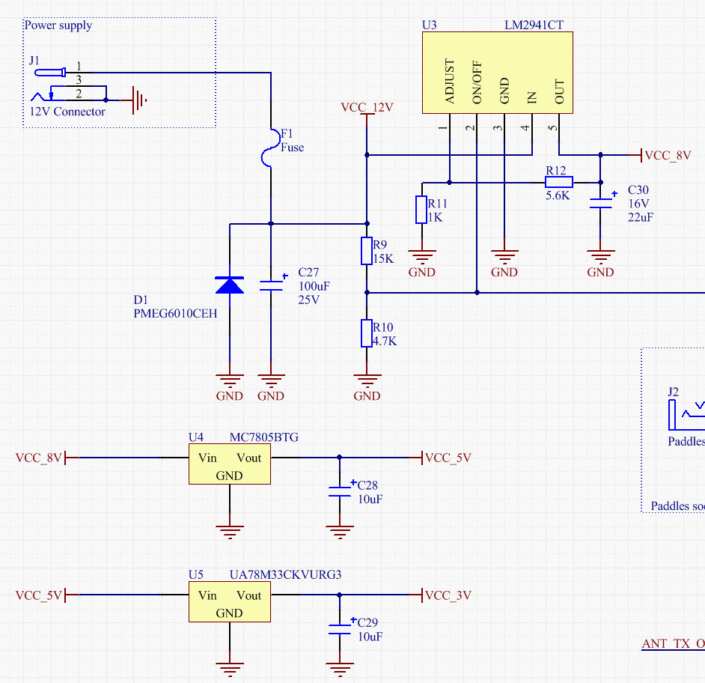

**Board Layouts**

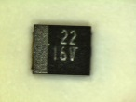**Board Top**

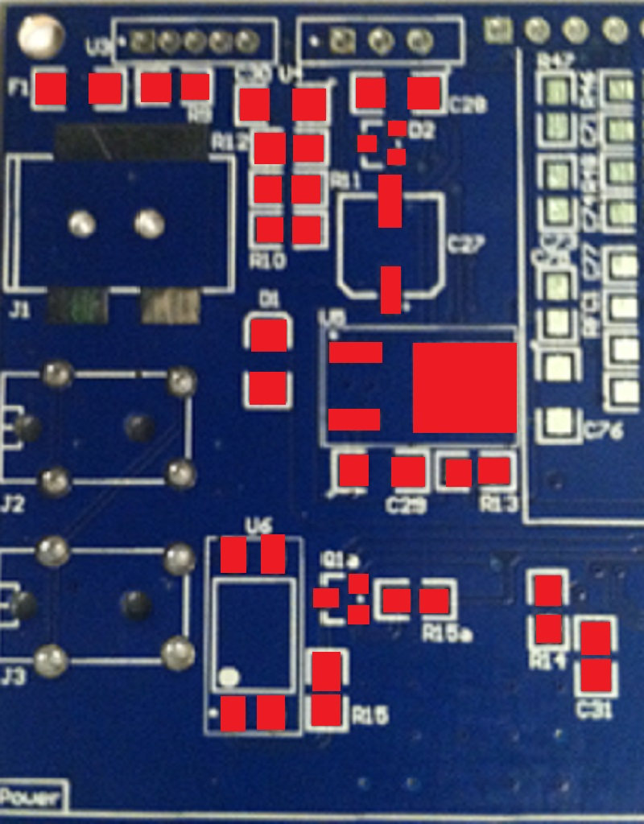

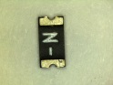

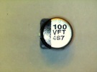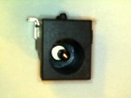

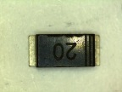

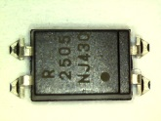

**Board Bottom**

 

**Power Supply Bill of Materials**

**Detailed Build Steps**

**Step_Install Topside Components**

Depending on how you decide to solder the parts by hand using solder and iron, or using solder paste and heat gun, or hot plate will depend on if you just solder part by part or a bunch at a time.

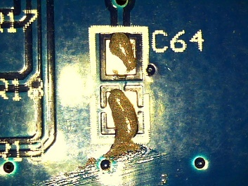I am going to show using solder paste in this part since I think it is new to most.

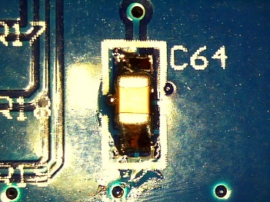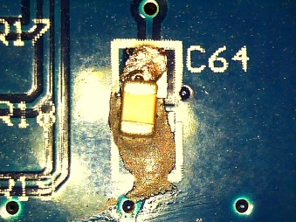To solder using paste first making sure you have the right parts using the BOM. Then take the syringe of paste and add a dab about the size of a Hersey kiss (at first little is better). If you get any paste in the wrong spot you can use rubbing alcohol to clean it up. Then once paste is on each pad that is getting parts place each part making sure they are the right orientation. When you apply heat the part will move a little bit into position (neat to watch). Then apply heat but watch out depending on the hot air gun you use the part might get moved. You will see the paste turn to a liquid and then will go bright silver. Then move to the next part until the parts are all soldered.

So with that out of the way, let’s start adding parts.

Add F1, R9, R11, R15, R14, R10, R15a, R12, R13 and C31 you don’t have to worry about which way they go as long as they are on both pads.

Now let’s add the parts that orientation does matter. C30, C28, D1, C29, U6, C27

This is C30 Look for the + on parts that have polarity this is a capacitor.

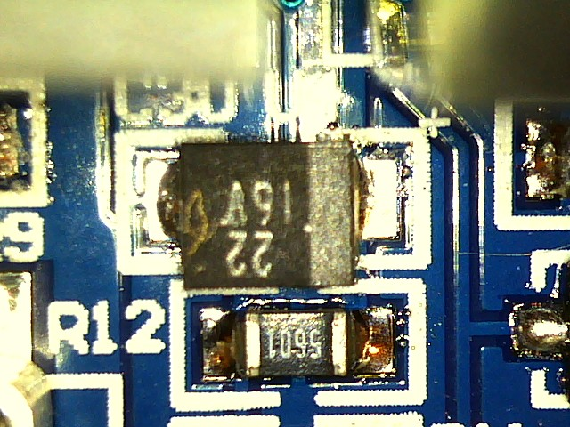

This is the positive side of the capacitor.



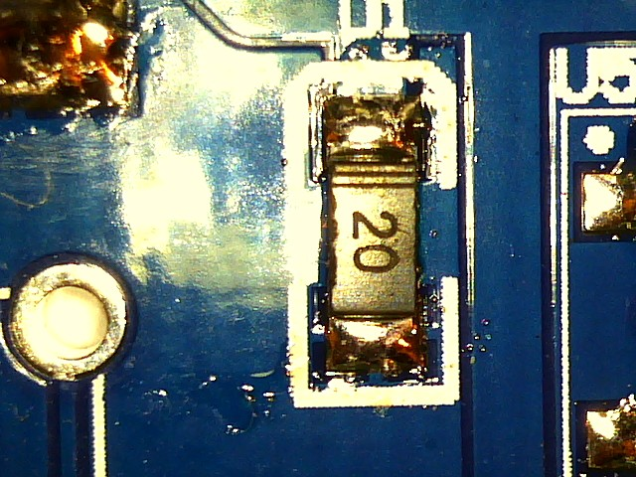

This is D1 on the RF power supply board it is tough to see but the lines get lined up with the top of the silkscreen

This is U6 which is the opto isolator for the push to talk circuit. See the dot is what you need to line up

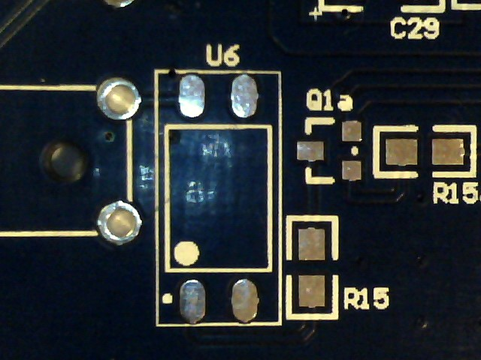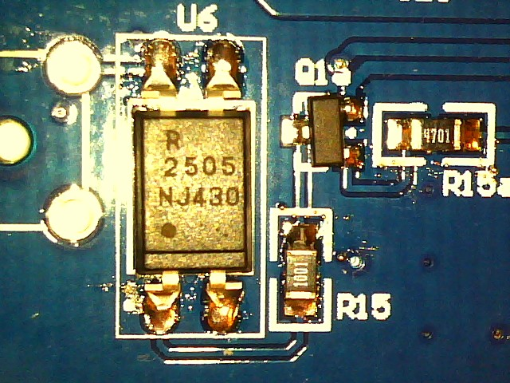

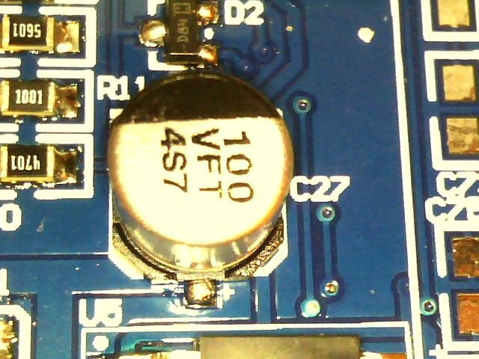

Here is C27 it is an Electrolytic Capacitor (I hate soldering these) you need to line up the diagonal sides with the silkscreen. (They are easier to solder with a hot air gun then an iron).

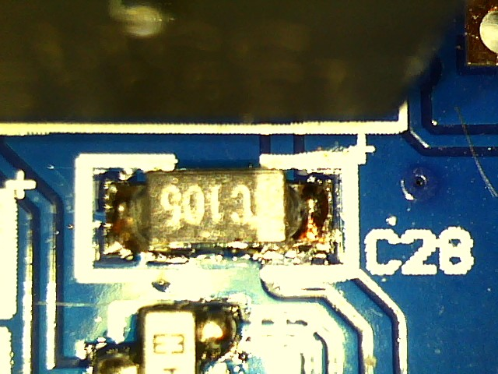

C28 and C29 are just like C30

Now add parts you need to hand solder. Jack, Header, U5, U3……

The Power jack can be soldered using the heat gun or by hand I have done both and found the heat gun does not melt the plastic.

Next solder U3, and U5 make sure you don’t have any solder bridges on U3 mainly on pin 2 because it can cause the power to be always on.

Also make sure that U3 and U5 is at the right height for a heat sink.

NOTE: also look at U3, U4, Q5, and Q6 to make sure they are at the same height. ( I found my Q5 and Q6 could only go in so far because of the pins.)

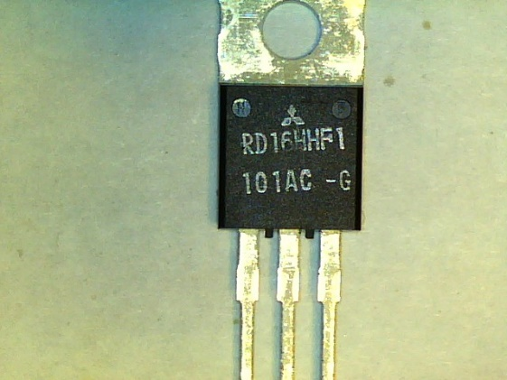 you need to look and see how far you can put the pins in because of the heat sink you will need to add later.

Then solder header P1 I soldered the female on my RF board and the male on my UI there is no right or wrong way I only did this so it would be the same on all my McHF radios.

**Completed Photos**

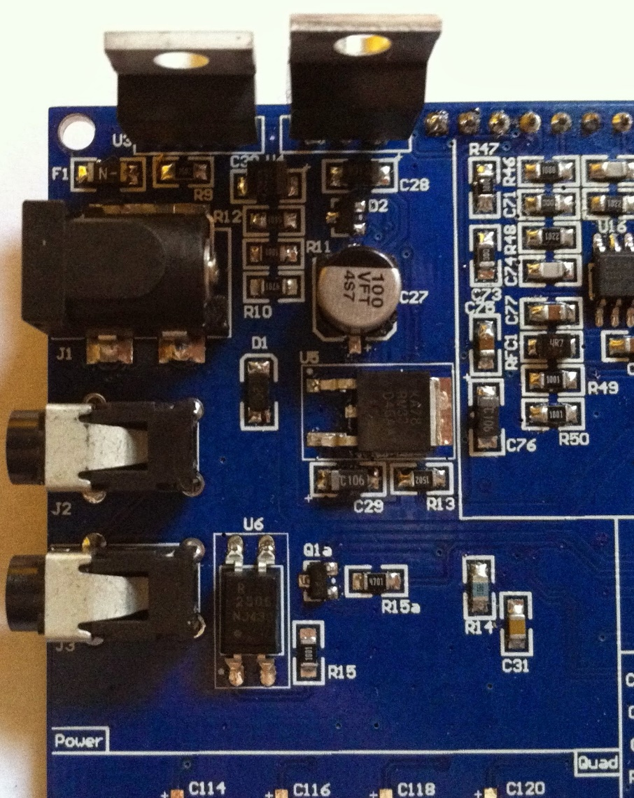

**View of Completed Topside**

**View of Completed Underside**

 

**Test the Power Supply Stage**

**Power Supply - Current draw**

Before applying power for the first time, test the resistance across the 12V power rail (positive lead at the point marked for the non-hairpin end of R52; negative lead on a convenient ground (see diagram below)). You should see a very high resistance (over 50 k ohms) and it should climb (as the electrolytic capacitors charge up with the ohmmeter's voltage). Ultimately, you should see an extremely high (or infinite) resistance.

Once you have successfully passed the resistance test, put your mA meter in series with the input voltage positive line and measure the current draw of the power supply.

See [Tutorial on Measuring Current](http://www.scienceshareware.com/how-to-measure-DC-current-with-a-dmm.htm) for an illustration of how to measure current in a circuit.

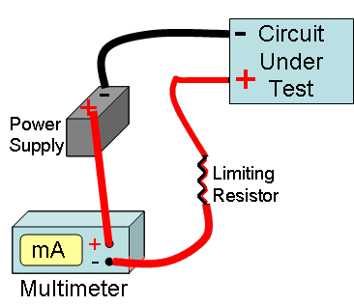   
Go to Top of Page

**Test Steps (if any)**

|  |  |  |  |  |  |
| --- | --- | --- | --- | --- | --- |
| **Step** | **Test Point** | **UOM** | **Nominal** | **Author's** | **Builder's** |
| 2 | Current draw | mA | < 8 | 4.5 |  |

Go to Top of Page

**Power Supply - Voltage Tests**

Power up the board with a 12V supply (no limiting resistor) and measure the voltage at the test points indicated.

(Author's measurements below were taken using power from a gel cel whose voltage measured 12.9V)

Voltage measurements are WRT regular ground. For this test you can use the "hairpin" of R50 as a convenient regular ground test point.

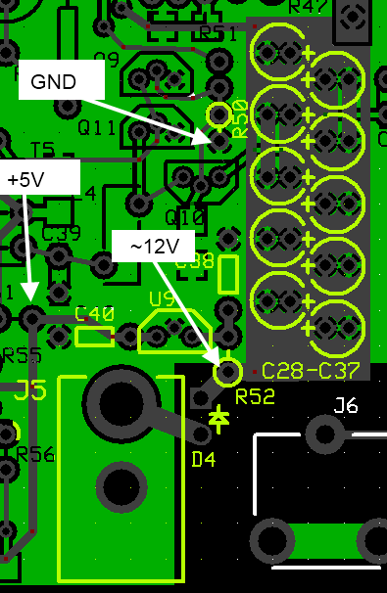   
Go to Top of Page

**Test Steps (if any)**

|  |  |  |  |  |  |
| --- | --- | --- | --- | --- | --- |
| **Step** | **Test Point** | **UOM** | **Nominal** | **Author's** | **Builder's** |
| 0 | Hairpin lead (hole) of R61 (wrt ground) | V dc | 5 (+/- 2%) | 4.94 |  |
| 1 | Hairpin lead of D4 (wrt ground) - (with 12.9 V gelcell) | V dc | 12 | 12.3 |  |

**Parts 2 McHF – UI 0.4 CPU   
Introduction**

**General Info about the Stage**

**This stage installs the CPU, buttons, rotary encoders, and LCD screen. It will also cover installing the boot loader and firmware. This will present the most difficult SMT soldering challenge to the builder. We will also cover the many different ways to solder the main CPU chip.**

**Theory of Operation**

The heart and soul of this transceiver is the STM32F4 microcontroller. It does all the control and DSP processing, implements the User Interface driver and provides all the functionality. It requires single 3V power supply and stable, 16 Mhz clock. The FOX924B TCXO provides that, where as option, simple quartz crystal could be used as well, if frequency stability is not required.

**Summary Build Notes**

1. [Install Topside Capacitors](http://www.wb5rvz.org/ensemble_rxtx/02_ps3#installtopsidecapacitors)
2. [Install SMT Components](http://www.wb5rvz.org/ensemble_rxtx/02_ps3#installsmtcomponents)
3. [Install Topside Connector](http://www.wb5rvz.org/ensemble_rxtx/02_ps3#installtopsideconnector)
4. [Test the Stage](http://www.wb5rvz.org/ensemble_rxtx/02_ps3#testing)

**Stage Schematic**

ADD PICTURE OF BOARD WITH PARTS

**Board Layouts**

**UI board CPU section Bill of Materials**

**Detailed Build Steps**

**Step_1 Install CPU..**

This is the heart of the UI board I recommend installing the CPU chip first. It can be soldered in a few different ways. I am going to cover using the heat gun first.

Heat gun soldering.

First add solder paste lay out a bead of paste on all 4 rows of the traces.

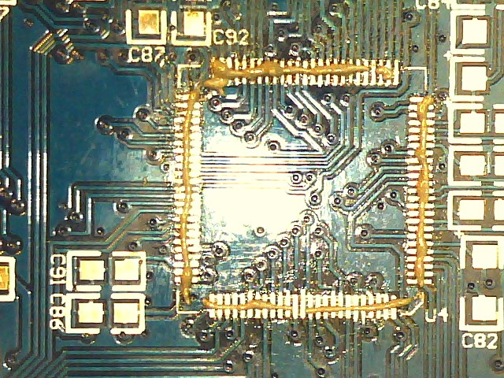

Then place the chip making sure you align the pins.

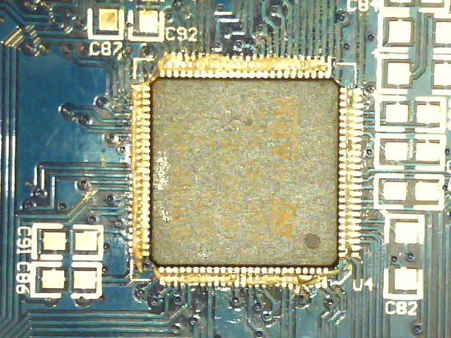

Then apply heat evenly to the pins.

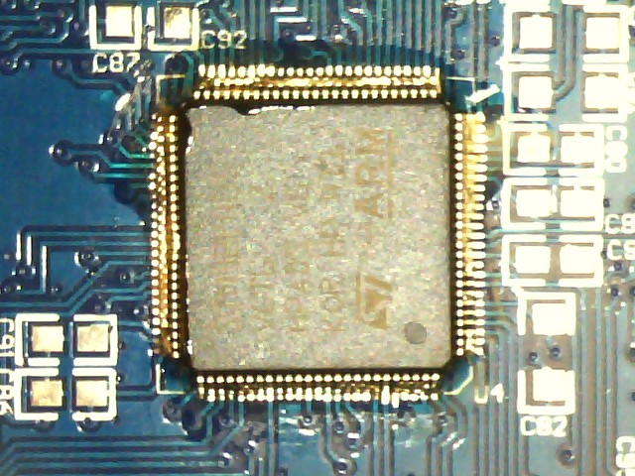

Once the solder is melted check for solder bridges and use desolder braid to remove the bridges.

ADD PICTURE OF DESOLDERIGN

Drag soldering.

Explain drag soldering

ADD install the rest of the parts

ADD HOW TO CURRENT TEST

**Parts 3 McHF – UI 0.4 Buttons and encoders**

**Introduction**

**General Info about the Stage**

**Theory of Operation**

**Summary Build Notes**

1. [Install Topside Capacitors](http://www.wb5rvz.org/ensemble_rxtx/02_ps3#installtopsidecapacitors)
2. [Install SMT Components](http://www.wb5rvz.org/ensemble_rxtx/02_ps3#installsmtcomponents)
3. [Install Topside Connector](http://www.wb5rvz.org/ensemble_rxtx/02_ps3#installtopsideconnector)
4. [Test the Stage](http://www.wb5rvz.org/ensemble_rxtx/02_ps3#testing)

**Stage Schematic**

ADD PICTURE OF BOARD WITH PARTS

**Board Layouts**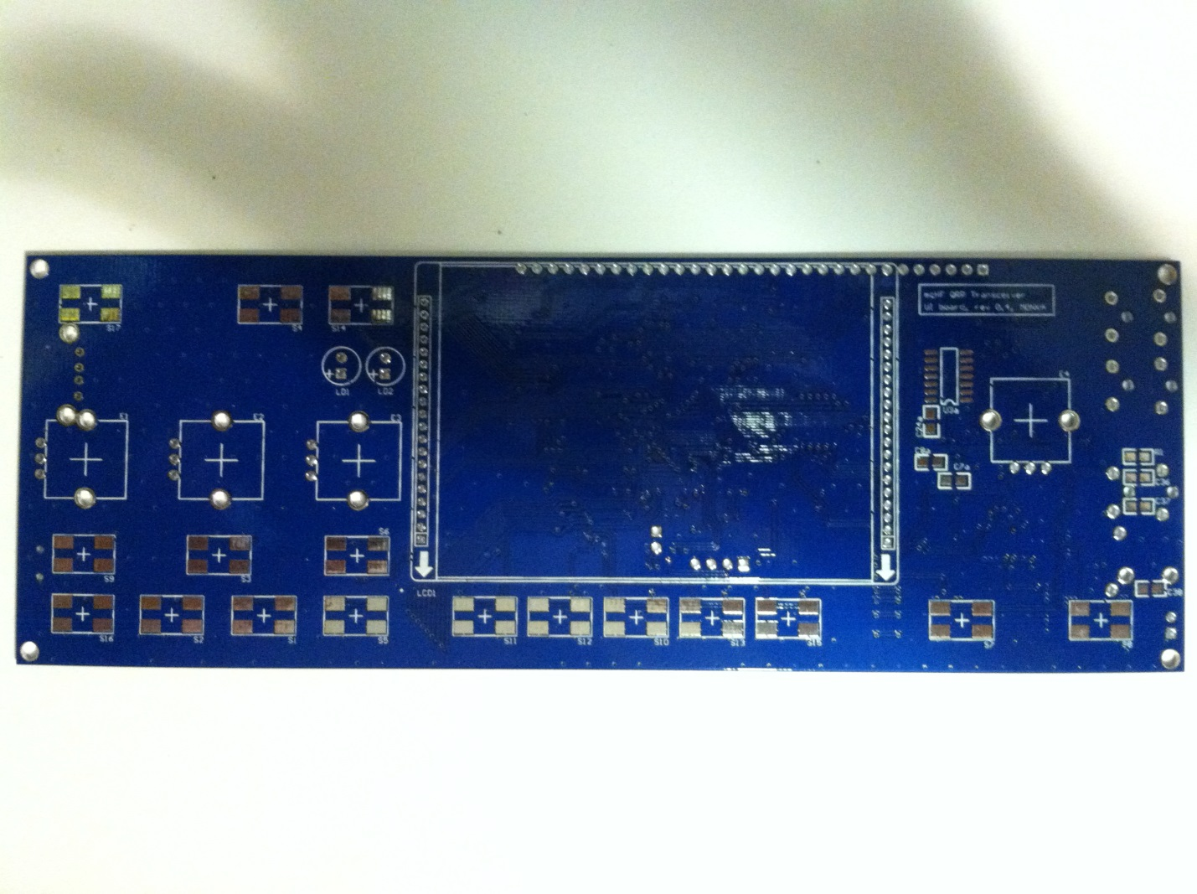

**UI board CPU section Bill of Materials**

**Detailed Build Steps**

**ADD HOW TO INSTALL THE PARTS**

**THEN CURRENT TEST**

**THEN INSTALL THE BOOT LOADER**

**Parts 4 McHF – UI 0.4 LCD Display**

**Introduction**

**General Info about the Stage**

**Theory of Operation**

**Summary Build Notes**

1. [Install Topside Capacitors](http://www.wb5rvz.org/ensemble_rxtx/02_ps3#installtopsidecapacitors)
2. [Install SMT Components](http://www.wb5rvz.org/ensemble_rxtx/02_ps3#installsmtcomponents)
3. [Install Topside Connector](http://www.wb5rvz.org/ensemble_rxtx/02_ps3#installtopsideconnector)
4. [Test the Stage](http://www.wb5rvz.org/ensemble_rxtx/02_ps3#testing)

**Stage Schematic**

ADD PICTURE OF BOARD WITH PARTS

**Board Layouts**

**UI board CPU section Bill of Materials**

**Detailed Build Steps**

**ADD HOW TO INSTALL THE DISPLAY**

**THEN HOW TO CURRENT TEST**

**THEN HOW TO INSTALL THE FIRMWARE**

**Parts 5 McHF – UI 0.4 Codec**

**Introduction**

**General Info about the Stage**

**Theory of Operation**

**Summary Build Notes**

1. [Install Topside Capacitors](http://www.wb5rvz.org/ensemble_rxtx/02_ps3#installtopsidecapacitors)
2. [Install SMT Components](http://www.wb5rvz.org/ensemble_rxtx/02_ps3#installsmtcomponents)
3. [Install Topside Connector](http://www.wb5rvz.org/ensemble_rxtx/02_ps3#installtopsideconnector)
4. [Test the Stage](http://www.wb5rvz.org/ensemble_rxtx/02_ps3#testing)

**Stage Schematic**

ADD PICTURE OF BOARD WITH PARTS

**Board Layouts**

**UI board CPU section Bill of Materials**

**Detailed Build Steps**

**ADD HOW TO INSTALL THE PARTS**

**ADD HOW TO CURRNET TEST**

**ADD HOW TO FUNCTION TEST**